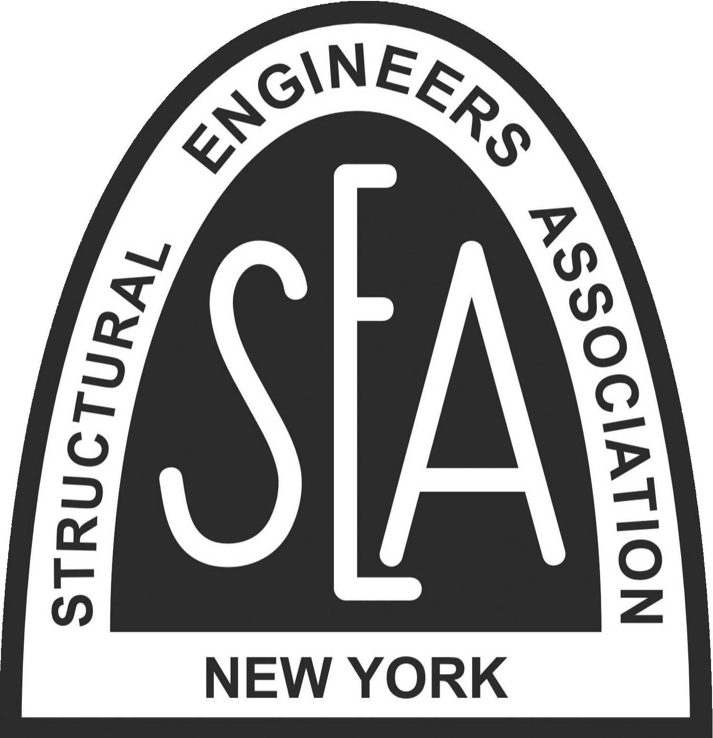
2022 SEAoNY EXCELLENCE IN
STRUCTURAL ENGINEERING AWARDS
CALL FOR ENTRIES

The Structural Engineers Association of New York (SEAoNY) announces the Call for Entries for the 2022 SEAoNY Excellence in Structural Engineering Awards Program. The purpose of the program is to recognize creative achievement and innovation in structural engineering.

ELIGIBILITY
Entry must be submitted by a current individual SEAoNY member in good standing.
Projects must have been substantially completed between January 1, 2020 and December 31, 2021 or must be sufficiently complete such that they clearly show the basic design of the structural system. The submittals will be judged based on the quality of the structural design portion of the project. Within the context of this awards program, “design” refers to the overall concept of any structure or structural system within a project. New projects, renovations, rehabilitation, structural upgrades and adaptive reuse of buildings, other structures, and bridges are eligible. Projects may be located anywhere in the world, but must have had the structural design completed by a firm or branch of a firm located in New York State. Projects completed by firms or offices of firms located outside New York State will not be considered. Each project will be considered separately and firms are encouraged to submit multiple projects. Projects that have won awards in other organizations are also encouraged to be entered. Non-winning projects from last year’s program may be resubmitted for the SEAoNY Award, provided they are still eligible based on completion date.

CATEGORIES OF AWARDS
Six awards will be presented across three project categories:
- New Buildings (up to 9 finalists with up to 3 awards)
- Forensic Analysis / Renovation / Retrofit / Rehabilitation of Structures (up to 3 finalists with 1 award)
- Other Structures (up to 3 finalists with 1 award)

One project will be awarded the Engineers’ Choice award.

RELATIONSHIP TO NCSEA AWARDS
The SEAoNY Awards are modeled after the National Council of Structural Engineers Associations (NCSEA) Excellence in Structural Engineering Awards. Entries to the SEAoNY Awards program may also be submitted to the NCSEA program, with the proper adjustments and the corresponding payment of the NCSEA entry fee. Find more information at http://www.ncsea.com/awards.aspx.

NEW BUILDINGS
New building projects will be submitted under a single category. Three awards will be given in this category. Projects may include any type of building that is occupied or used by people, including parking garages, airport control towers, industrial buildings, and similar structures.

FORENSIC ANALYSIS / RENOVATION / RETROFIT / REHABILITATION OF STRUCTURES
This category includes forensic analysis, structural renovations, seismic retrofits, adaptive reuse, rehabilitation of existing buildings or bridges, and similar projects. One award will be given in this category.

OTHER STRUCTURES
This category includes all non-building structures, such as towers, monuments, sculptures, art installations, pavilions, and similar projects. Bridges and other transportation structures may also be submitted such as vehicle and pedestrian bridges, highway structures, pipe or utility support spans, and similar structures. Projects may be of any span length or overall size. One award will be given in this category.

ENGINEERS’ CHOICE AWARD
All finalists considered for awards will be entered for the Engineers’ Choice Award. An electronic poll to select the winner will be opened to the public. Notification of the polling site will be disseminated on various social media platforms. Please note that one project photo and the 100-word description included in the entry submission will be used for the online poll.
JURY OF AWARDS
The selection of award recipients will be made by a distinguished Jury of Awards consisting of past presidents and honorary members of SEAoNY, members of structural engineering academia, and/or leading AEC industry professionals. There will be a minimum of five jurors.

JUDGING CRITERIA
- Creativity of structural design (20%)
- Complexity of criteria or unique problems (20%)
- Innovative application of new or existing materials or techniques (20%)
- Ingenuity of design for efficient use of materials and labor (20%)
- Exceeding client / owner’s needs or expectations (10%)
- Suitability of the structure for its environment and sustainability of design, including social, economic and environmental design considerations (10%)

The manner in which these criteria apply to the entry should be described in the submitted documentation

2022 SEAoNY AWARDS COMMITTEE
The 2022 Awards Committee is chaired by Fay Luo and Sarrah Kahn. Send any questions via email to: SEAoNY.Awards@gmail.com and seaonyprograms@gmail.com.

SUBMISSION OF ENTRIES
Entries must be e-mailed to: seaony.awards@gmail.com
All entries must be received no later than 5:00 PM EST on Friday, May 27, 2022. The maximum size of the email is 10MB. Each project entry must be submitted as a combined PDF with all letter-sized pages (8.5”x11”) and should include the following material:
- The completed and signed SEAoNY entry form (included)
- A description of the entry outlining the significant aspects of the entry and their relationship to the six relevant judging criteria (800 words maximum)
- A summary of the entry to be used in publications (100 words maximum)
- Photographs during construction and of the completed structure (A minimum of 4 and not more than 8). You must have permission to use the photographs and be able to grant rights to publication as detailed below.
- Provide ONE JPG or PNG image file for the Engineers’ Choice Award.
- Plans or sketches may be included (not more than two pages total)
- Entry fees are accepted online at: https://www.seaony.org/event-4782772
A check for the entry fee may be mailed to:
SEAoNY c/o Jaffe management
555 8th Ave, Suite 1902
New York, NY 10018
(646) 736-0694

ENTRY FEE
There is a $100 member (log in for this pricing)/$150 nonmember fee per award entry.
Sustaining members of SEAoNY may submit entries for free based on their membership status:
Platinum member may submit up to 3 entries for free
Gold member may submit up to 2 entries for free
Silver member may submit up to 1 entry for free

SUBMISSION OF ENTRIES – FOR FINALISTS
The finalist projects in each category will be required to provide SEAoNY with the following for use in publications and announcements, and for the awards presentation ceremony. Please consider this requirement if entering multiple projects:
- One foam-core poster board (30”x40”) for display during the 2020 SEAoNY Boat Cruise (Must be brought to the boat cruise in person)
- Credits that must be noted for all photographs

NOTIFICATION OF AWARD
The finalists in each category will be notified in writing after selection by the Jury of Awards. The recipients of the Outstanding Project Award will be announced at the awards presentation.

PRESENTATION OF AWARDS
The awards will be presented at the SEAoNY Annual Boat Cruise on June 27th, 2022.

OWNERSHIP AND PUBLICATION OF ENTRIES
All entries are the property of SEAoNY and will not be returned. SEAoNY reserves the right to use or publish entries and accompanying materials in the SEAoNY newsletter Cross Sections, the SEAoNY website, or any other SEAONY-related publications. By submitting an entry, the entrant grants a royalty-free license to SEAoNY to use any copyrighted material submitted.
2022 SEAoNY EXCELLENCE IN
STRUCTURAL ENGINEERING AWARDS
ENTRY FORM

Project Category (check one):
____ New Buildings

____ Forensic Analysis / Renovation / Retrofit / Rehabilitation of Structures

____ Other Structures

Name of Project: ____________________________________________________________________________
Approximate construction cost:
☐ less than $10M ☐ $10M to $30M ☐ $30M to $100M ☐ $100M to $300M ☐ Over $300M
Approximate square footage of entry: _____________________________________________________________
Location of Project: ___________________________________________________________________________
Is the project LEED-certified? If so, what is the level of certification? ____________________________________
Date construction completed (M/Y): ______________________________________________________________
Structural design firm: ________________________________________________________________________
Number of employees (check one): ☐ 10 or less ☐ 11 to 50 ☐ 51 or more
Architect: ___________________________________________________________________________________
General contractor: ___________________________________________________________________________
By signing below, the signatory agrees to the following and indicates that he or she is authorized to sign for the structural design firm of record:
All entries become the property of SEAoNY and will not be returned. If the entry submitted is one of the three winning entries in its category, SEAoNY is hereby granted the right to use or publish entries and accompanying materials in the SEAoNY newsletter Cross Sections, the SEAoNY website, or any other publications; and in addition, a royalty-free license is granted to SEAoNY to use any copyrighted material submitted.
Submitted by: _______________________________________________________________________________
Print name Signature Date
Submitting Firm: _____________________________________________________________________________
Mailing address: _____________________________________________________________________________
Telephone: ___________________________________ Email: _______________________________________

2022 SEAoNY EXCELLENCE IN
STRUCTURAL ENGINEERING AWARDS
ENTRY FORM

In addition to the 800-words and 100-words project description, in less than 3 sentences, please describe how the project fulfills each award criteria.

Creativity of structural design (20%)

Complexity of criteria or unique problems (20%)

Innovative application of new or existing materials or techniques (20%)

Ingenuity of design for efficient use of materials and labor (20%)

Exceeding client / owner’s needs or expectations (10%)

Suitability of the structure for its environment and sustainability of design, including social, economic and environmental design considerations (10%)

